
Discover Onelake
Data 034 – Optional lab

September 22, 2026
Waleed Butt

Contents
Make a Workspace 2
Make a Lakehouse and load sample data 3
Load data into a Table 5
Browse the OneLake catalog to discover data 7
Explore lakehouse tables and schema 8
Create a shortcut to access data from another workspace 9
Query data using the SQL analytics endpoint 11
Create and explore a semantic model 12
Wrap up 14

DISCOVER ONELAKE

In an organization there are many ways to store and use data. Different teams use different technology and approaches to consuming and using data. One team may use lakehouse to store and cleansed data others may use warehouses with business metrics and some may use semantic models. This is where OneLake catalog comes in. It helps in searching for data assets, meta data and understand whats available in organization. Once you find what you need you can connect through it directly or through shortcuts, query it using SQL or explore it through onelake catalog.

In this lab we will create a workspace and then a lakehouse, add data to it and then query that data for info.

Make a Workspace
- Sign in to your fabric account.
- On the left side hub there is option for workspaces or cards in the center of the fabric will have new workspace, click on it.
- A window will slide out from the right put in a name of your choice for the workspace for example; sales_data_workspace
- Click apply and fabric will create a new workspace which will like this
Figure 1 Empty workspace
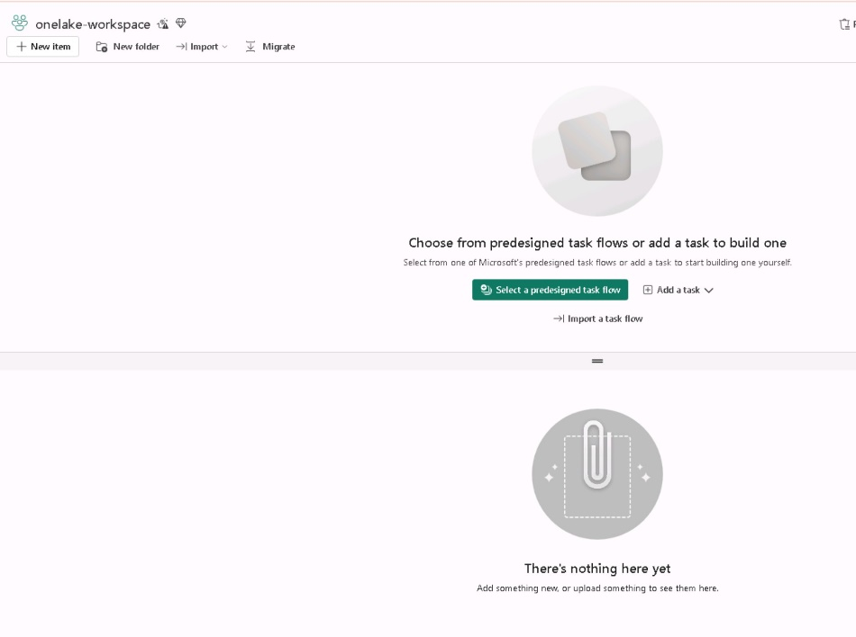

Make a Lakehouse and load sample data
Now that you have a workspace, it’s time to create a lakehouse and populate it with sample sales data. This lakehouse represents data that a data engineering team might have already created in a real organization.
- In your workspace, select + New item, and then select Lakehouse. Give it a name of your choice (for example, onelake_lakehouse). After a minute or so, a new lakehouse with empty Tables and Files folders will be created. It will look like the image below
Figure 2 Empty lakehouse
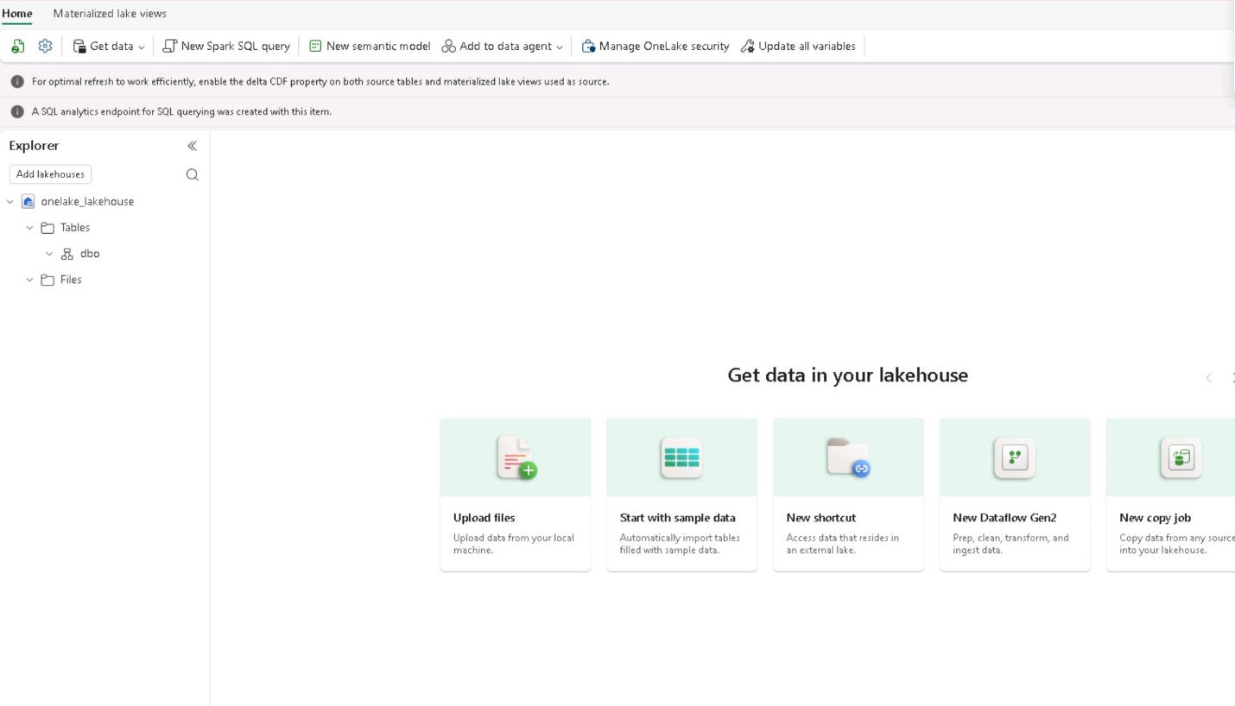
- Download a csv file from https://raw.githubusercontent.com/MicrosoftLearning/dp-data/main/sales.csv and save it on your computer. Most likely default folder will be downloads.
- In the lakehouse highlight the Files folder and select the menu options, the three ellipsis “…”, and Upload > Upload Files and then browse to the sales.csv on your computer and upload that.
Figure 3 Files folder upload files menu option
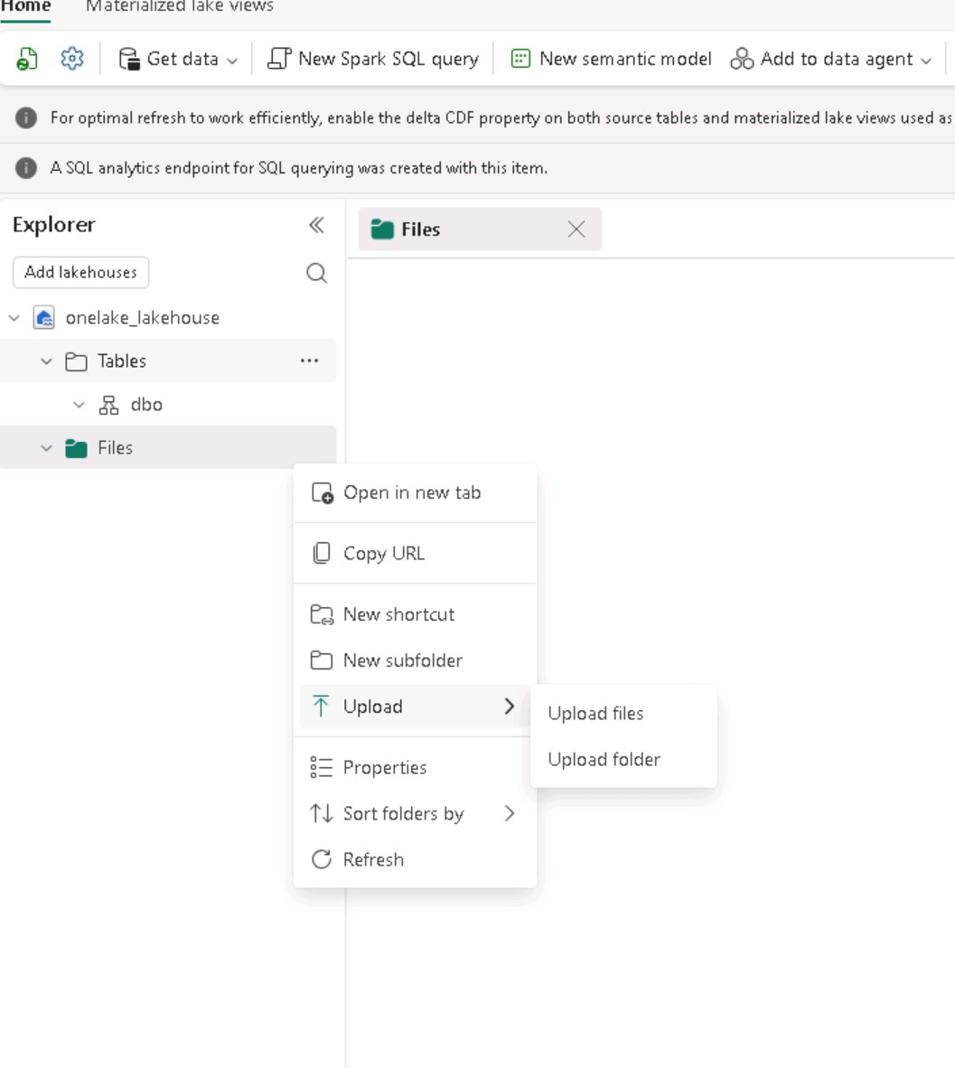
- Once upload you can go back to the Files Folder and in the “…” click on Refresh
- Highlighting the Files folder you can see sales.csv file in the preview pane on the right
- On selecting the sales.csv file you can see the preview of the content
Figure 4 Sales.csv uploaded to lakehouse
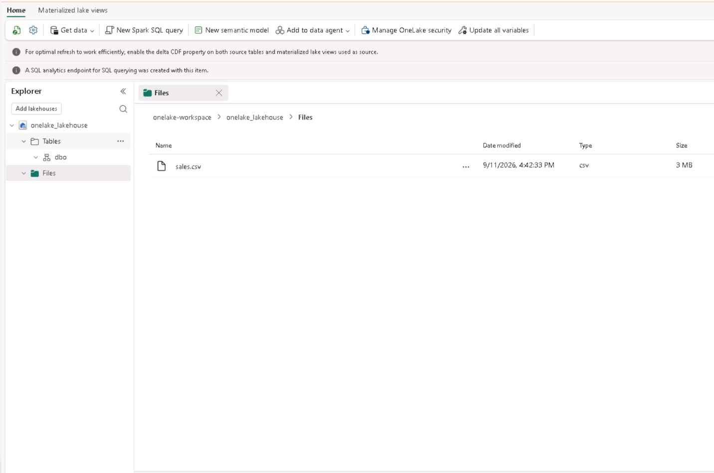

Load data into a Table
Loading file data into a Delta table makes it queryable using SQL and provides reliability features like ACID transactions, which are similar to a traditional data warehouse.
- In the explorer pane expand Files folder and in the preview pane on the right highlight sales.csv file.
- In the “…” menu for sales.csv click on Load to Tables > New Table.
Figure 5 Load to Table menu option
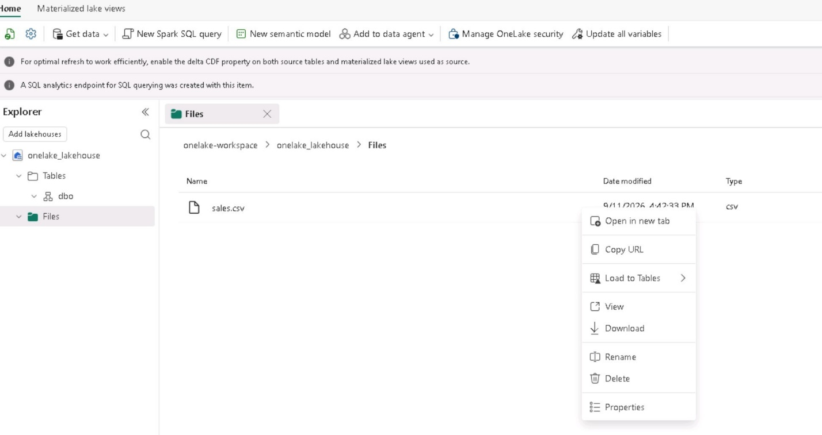
- In the Load to Table dialog box put in the name of the table as sales and confirm. Wait for the table to be created.
- In the explorer pane open the Tables folder and then select sales table to see the table and its schema in the preview pane.
Figure 6 Delta table created for sales
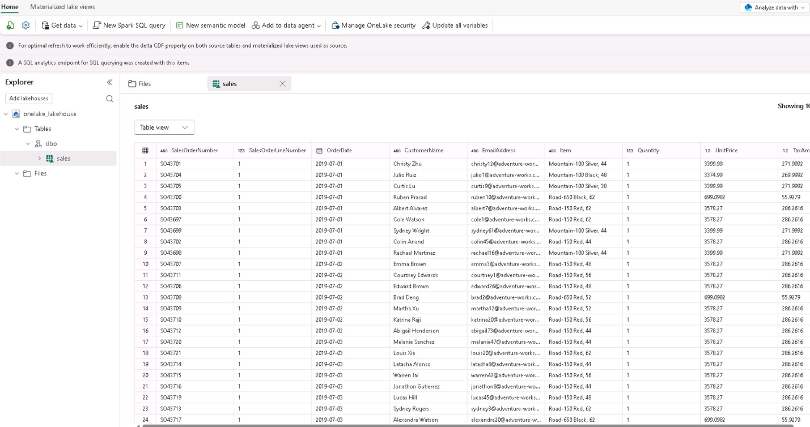

Browse the OneLake catalog to discover data
Now that you have data in your lakehouse, you can explore how to discover it through the OneLake catalog. The catalog provides a centralized view of all data assets across your Fabric tenant.
- At the top of the page, select Fabric icon to return to Fabric home page.
- From the left navigation pane/hub select OneLake catalog.
- In the catalog select Explore tab.
- In the catalog, you will see your various items being used like lakehouses, warehouses, semantic models, and reports.
Figure 7 Catalog view
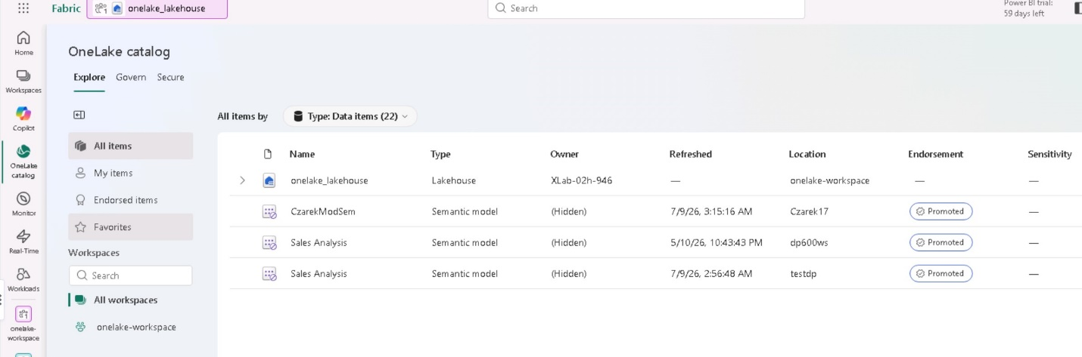
- Select your lakehouse. For example, onelake_lakehouse, to view its details.
Figure 8 Lakehouse details.
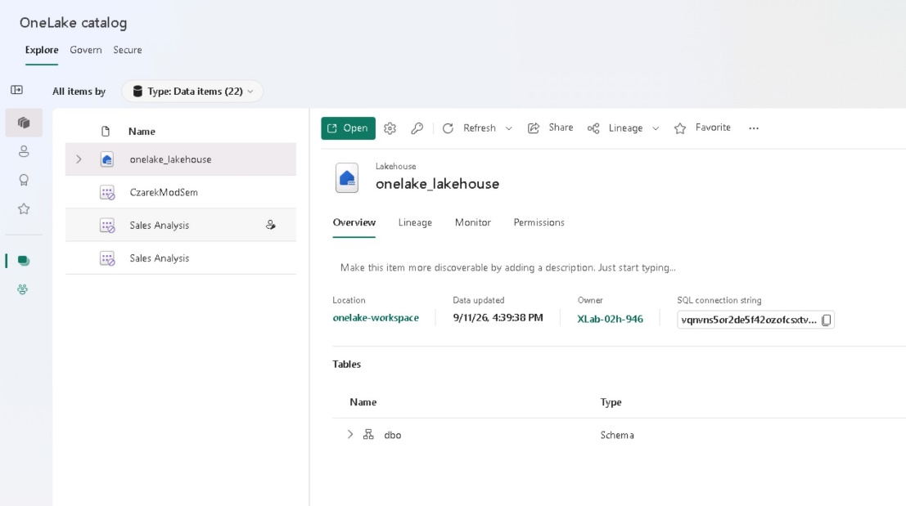

Explore lakehouse tables and schema
After discovering a data asset in the catalog, the next step is to explore its structure. Understanding the tables, columns, and data types helps you determine whether the data meets your needs.
- If you are in the catalog view select your lakehouse and open it
- In the explorer pane on the left select and open Tables folder and highlight your table sales.
- In the preview pane you will see the table with its headers and each header / column will show the data.
- Expand the sales tables in the explorer pane to see its schema and datatypes.
Figure 9 Schema and datatypes of sales table
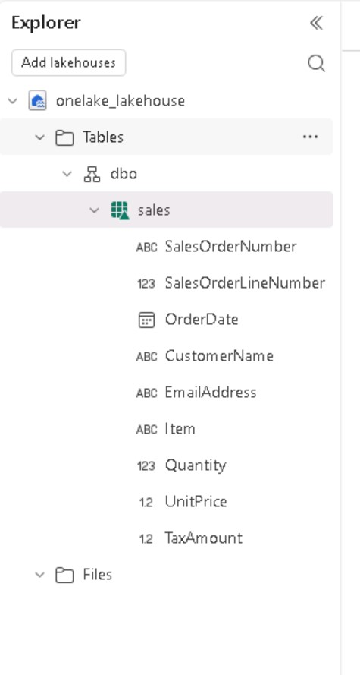
- In the preview pane above the table select File View to see the underline files.
- It consists of Parquet files in delta lake format. The _delta_log_ subfolder contains transactions logs that track all changes made to the table, enabling ACID transactions and time travel.
Figure 10 File view
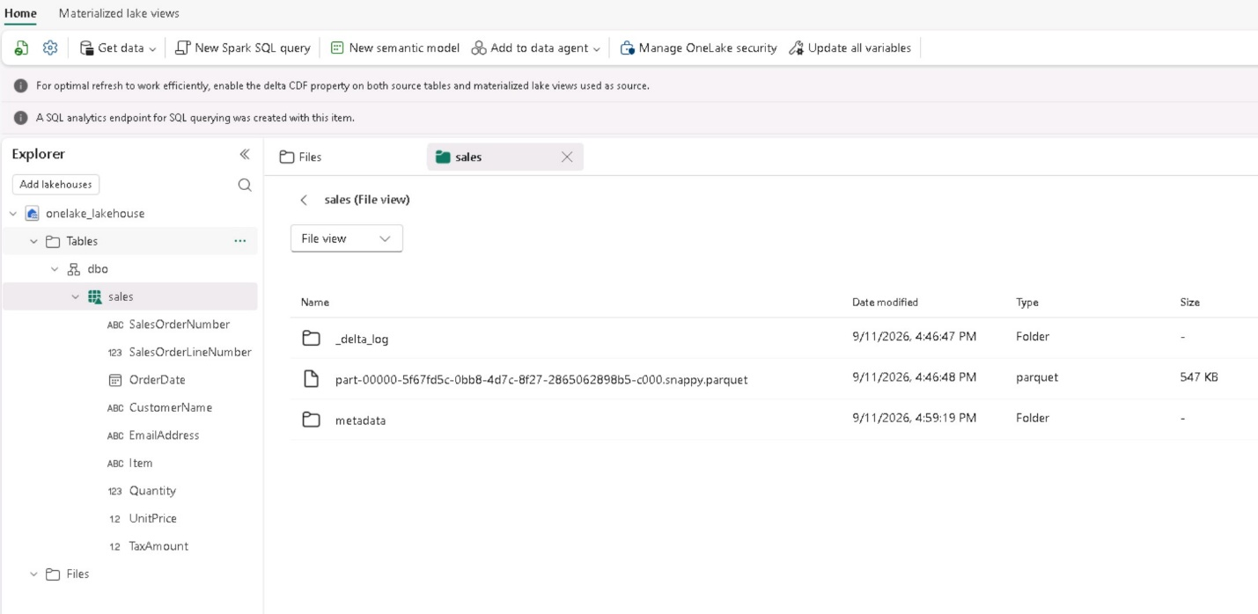

Create a shortcut to access data from another workspace
Shortcuts let you reference data from other workspaces without copying it, providing a live connection to the source. In this task, you create a second lakehouse and a shortcut pointing to the sales data in your original lakehouse.
- Go back to your workspace.
- Make a new lakehouse and name it analytics, assuming we will do our analytics in this lakehouse.
- Expand the Table folder and click on the “…” ellipsis menu to open the menu.
- Click on New schema shortcut menuitem.
Figure 11 New schema shortcut
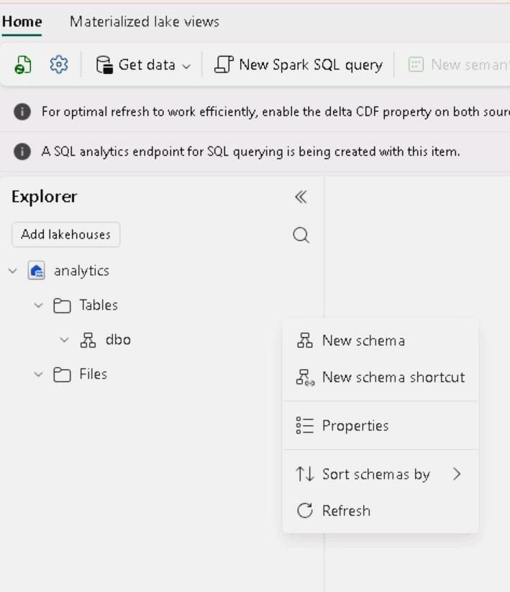
- A Select a data source type window will open up. Select your original lakehouse onelake_lakehouse, click Next and connection method window will popup, choose recommended and connect
- The window will show your onelake_lakehouse, select the sales table and click Next and then Create.
Figure 12 New short cut created to original lakehouse
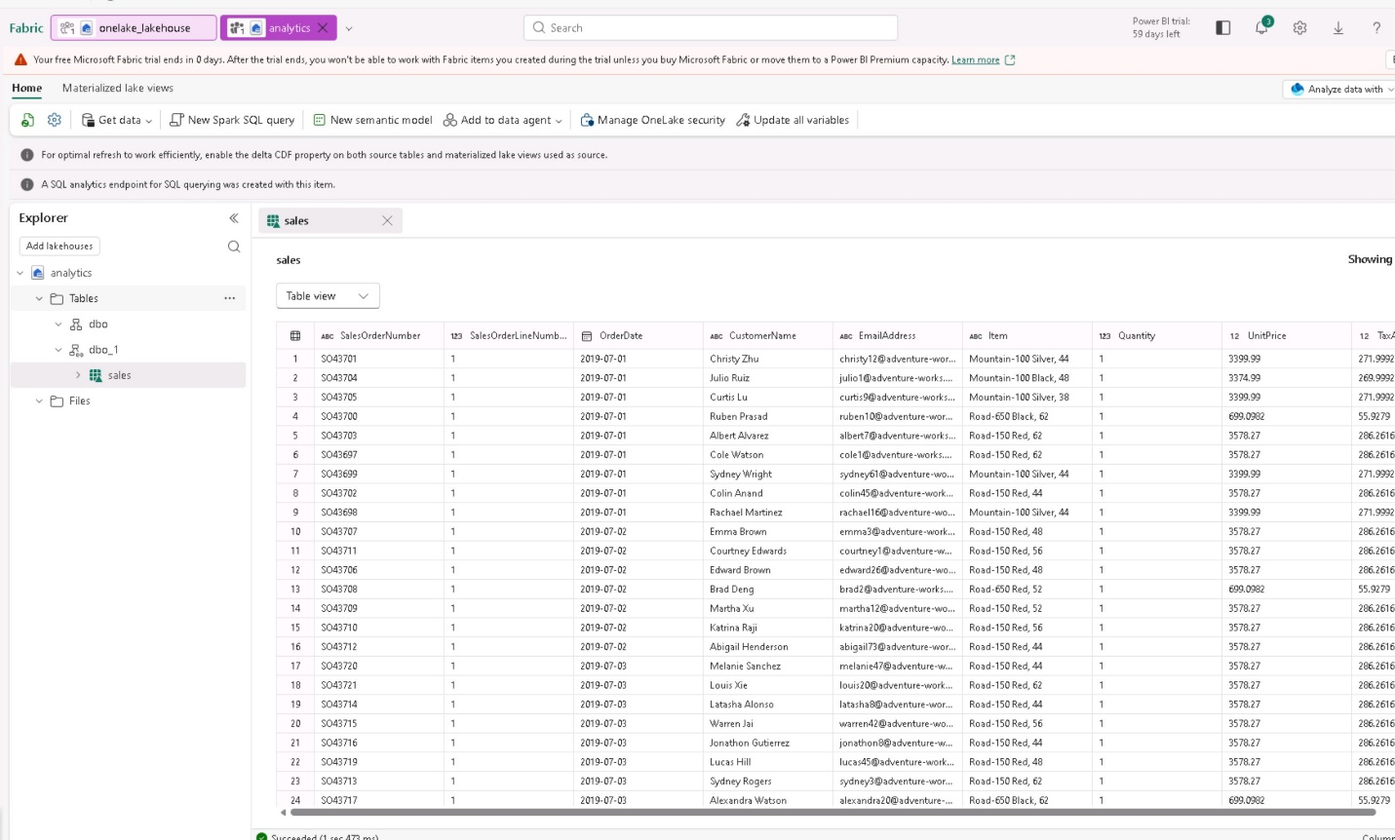

Query data using the SQL analytics endpoint
Every lakehouse includes a SQL analytics endpoint that provides read-only T-SQL access to tables. This endpoint enables you to query lakehouse data using familiar SQL syntax, making it easy to explore data and verify it contains what you need.
- On the top-right of your analytics lakehouse look for a drop down menu that says Analyze data with … and choose SQL analytics endpoint. The interface changes to SQL-focused where we can use T-SQL to query the data.
- On the toolbar click on the New SQL query.
- Enter the SQL query as shown in the image and click run. You will see the results below the query
Figure 13 SQL endpoint and query result
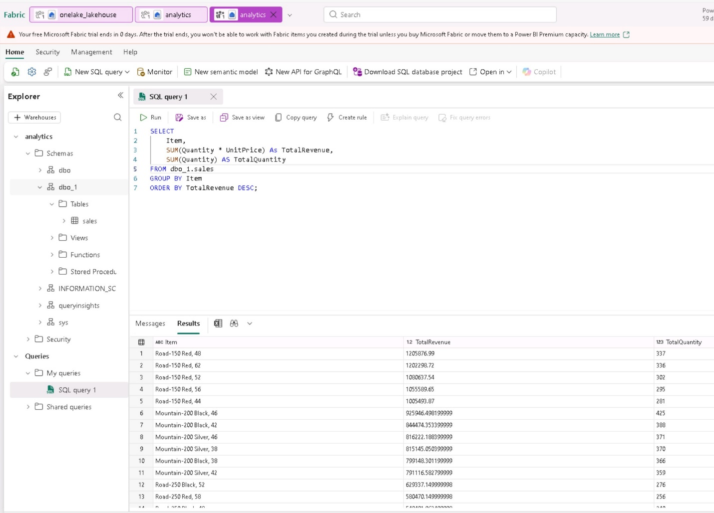
- Now you can modify the current query or create a new query to further your analysis.

Create and explore a semantic model
Semantic models provide a business-friendly layer on top of data, including predefined relationships, measures, and calculations for Power BI reports. In this task, you create a semantic model from the lakehouse and explore it using the Explore this data feature.
- While still in SQL analytics endpoint, on the toolbar click on New semantic model and new semantic model window opens up.
- In the New semantic model dialog window, makes sure the sales table is selected
- Give it a name like Sales Analysis. Click Confirm.
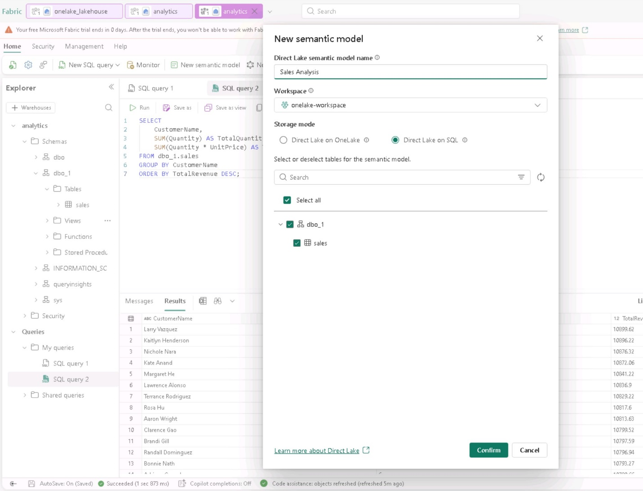
- Now navigate back to your workspace and select the “…” menu on the semantic model you just created and then click explore data.
Figure 14 workspace containing the new semantic model just created
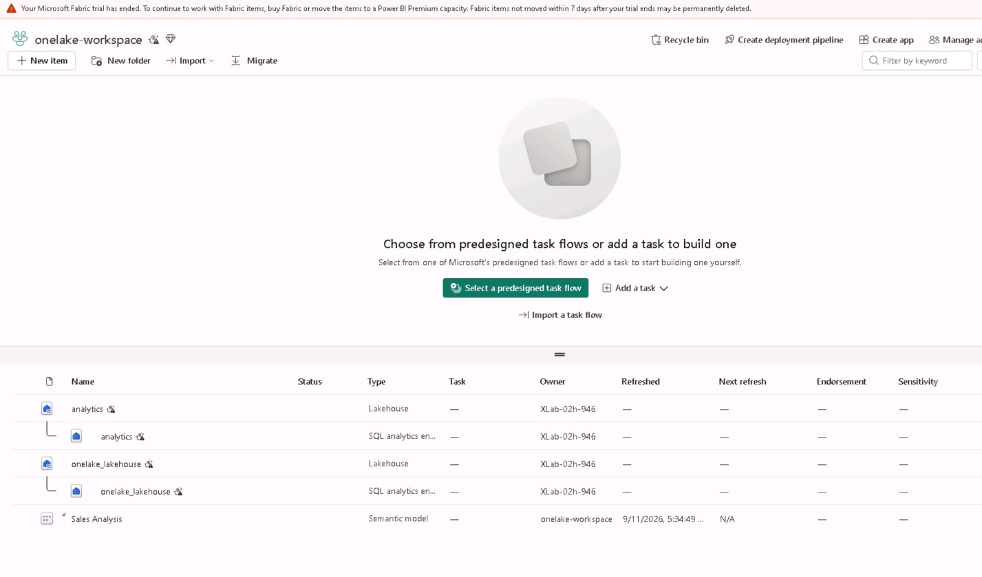

- This will open up a window where you can explore data using visualization.
- You can now drag and drop item fom the Data pane and even add Quantity and this will show the table with Item and Sum of Quantity.
- In the Visual pane you can choose the graph type you need and in the rearrange data pane you can move things in different axis.

Wrap up
Here we learned how to utilize the power of Onelake and its various features using lakehouse in Fabric. We can store data in different formats and use SQL endpoints to query. We can convert from unstructured to structured data directly in the lakehouse and then create a shortcut to the Table for analysis purposes.
And the end of everything is done make sure you clean up the resources by deleting your workspace.

